Telus UIV NOrC Backup Restore MOP
Document Control Item | Information
Author | Venkata Sudhakar/Abdul Khaliq
Owner | Siva Bodicherla
Approver | Siva Bodicherla
Organization | NOKIA
Document type | Internal (MOP)
Document version | V0.2
Document Location

Change history
Ver | Status | Date | Author | Owner | Reviewed by | Reviewed date | Approver | Approval date | Description of changes
0.1 | Draft | 2026-04-03 | Venkata Sudhakar/Abdul Khaliq | Siva Bodicherla | Siva Bodicherla |  |  |  | Backup and restore on preprod
0.2 | Draft | 2026-04-07 | Venkata Sudhakar/Abdul Khaliq | Siva Bodicherla | Siva Bodicherla |  | Siva Bodicherla |  | Backup and restore on preprod
1.0 | Approved | YYYY-MM-DD | Name | Name | Name | YYYY-MM-DD | Name | YYYY-MM-DD | Comments

Contents
Change history 1
1 Scope 4
2 Product SW Release Information 5
3 Namespace Information 6
4 Pre-checks 7
4.1 Verification of orders in OrderHub UI 7
4.2 Verify backups 8
4.2.1 Verification of UIV DB backups 8
4.2.2 Verification of NOrC DB backups 9
4.3 Identify helm name of DBs 9
5 Activity Overview 11
6 Backup Procedure and verification 12
6.1 On-demand backup of DBs 12
6.1.1 Backup of UIV neo4j DB 12
6.1.2 Backup of UIV mariadb DB 13
6.1.3 Backup of NOrC cassandra DB 14
6.1.4 Backup of NOrC CMDB DB 16
6.1.5 Backup of NOrC cmgo DB 17
6.2 Verification of DB backups created 18
6.2.1 Verification of on-demand UIV DB backup 18
6.2.2 Verification of on-demand NOrC DB backup 19
7 Data purging and verification 20
7.1 Data purging of Cassandra DB 20
7.2 Data purging of neo4j DB 21
7.2.1 Verification of data count pre purge activity 21
7.2.2 Purging data activity 21
7.2.3 Verification of data count post purge activity 21
7.3 Data purging of cmgo DB 22
7.3.1 Verification of data count pre purge activity 22
7.3.2 Purging data activity 23
7.3.3 Verification of data count post purge activity 23
7.3.4 Verification of OrderHub UI 23
8 Restore DB data and verification 25
8.1 Restore of DB from on-demand backup 25
8.1.1 Restore of neo4j DB 25
8.1.2 Restore mariadb DB 26
8.1.3 Restore cassandra DB 28
8.1.4 Restore cmdb DB 29
8.1.5 Restore cmgo DB 30
8.2 Verification post restore activity 32
8.2.1 Verification of cbur pod logs 32
8.2.2 Verification of data count post restore activity 33
8.2.3 Verification of OrderHub UI 34

Scope
This document defines the procedure for backup and restoration of UIV25 and NOrC platform in pre-production of Telus environment with specific use cases related to backup of Order which were provisioning and activated and restore scenario of these orders with the same state.

Product SW Release Information
Below are the Software versions on which the backup and restore is performed
Nokia Application | Base Version Deployed
UIV | 2507 MP1
NOrC | 25 SP1

Namespace Information
Below are the namespaces used for pre-prod Cluster deployment.
Namespace Name
doc-uiv
doc-norc

Pre-checks

Verification of orders in OrderHub UI
Verify order IDs created are visible in OrderHub UI for
- Create [Create (In Progress)]
- Activate [Create → Activate (In Progress)]
- Deactivate [Create → Activate → Deactivate (In Progress / Complete)]
- Terminate [Create → Terminate (In Progress)]
Output of order IDs created by testing team:
Create Order id: 89e64a9d-17f9-4e2c-8403-18cb3b42f2d0
Activate Order id: 9c32083f-105d-4d51-9dba-cb8c3a944591
Deactivate Order id: e6707eba-50c8-4b73-bc05-ad0010e3ba01
Terminate Order id: f7d799ca-cba2-4edd-8de6-6ba1ec95d5de

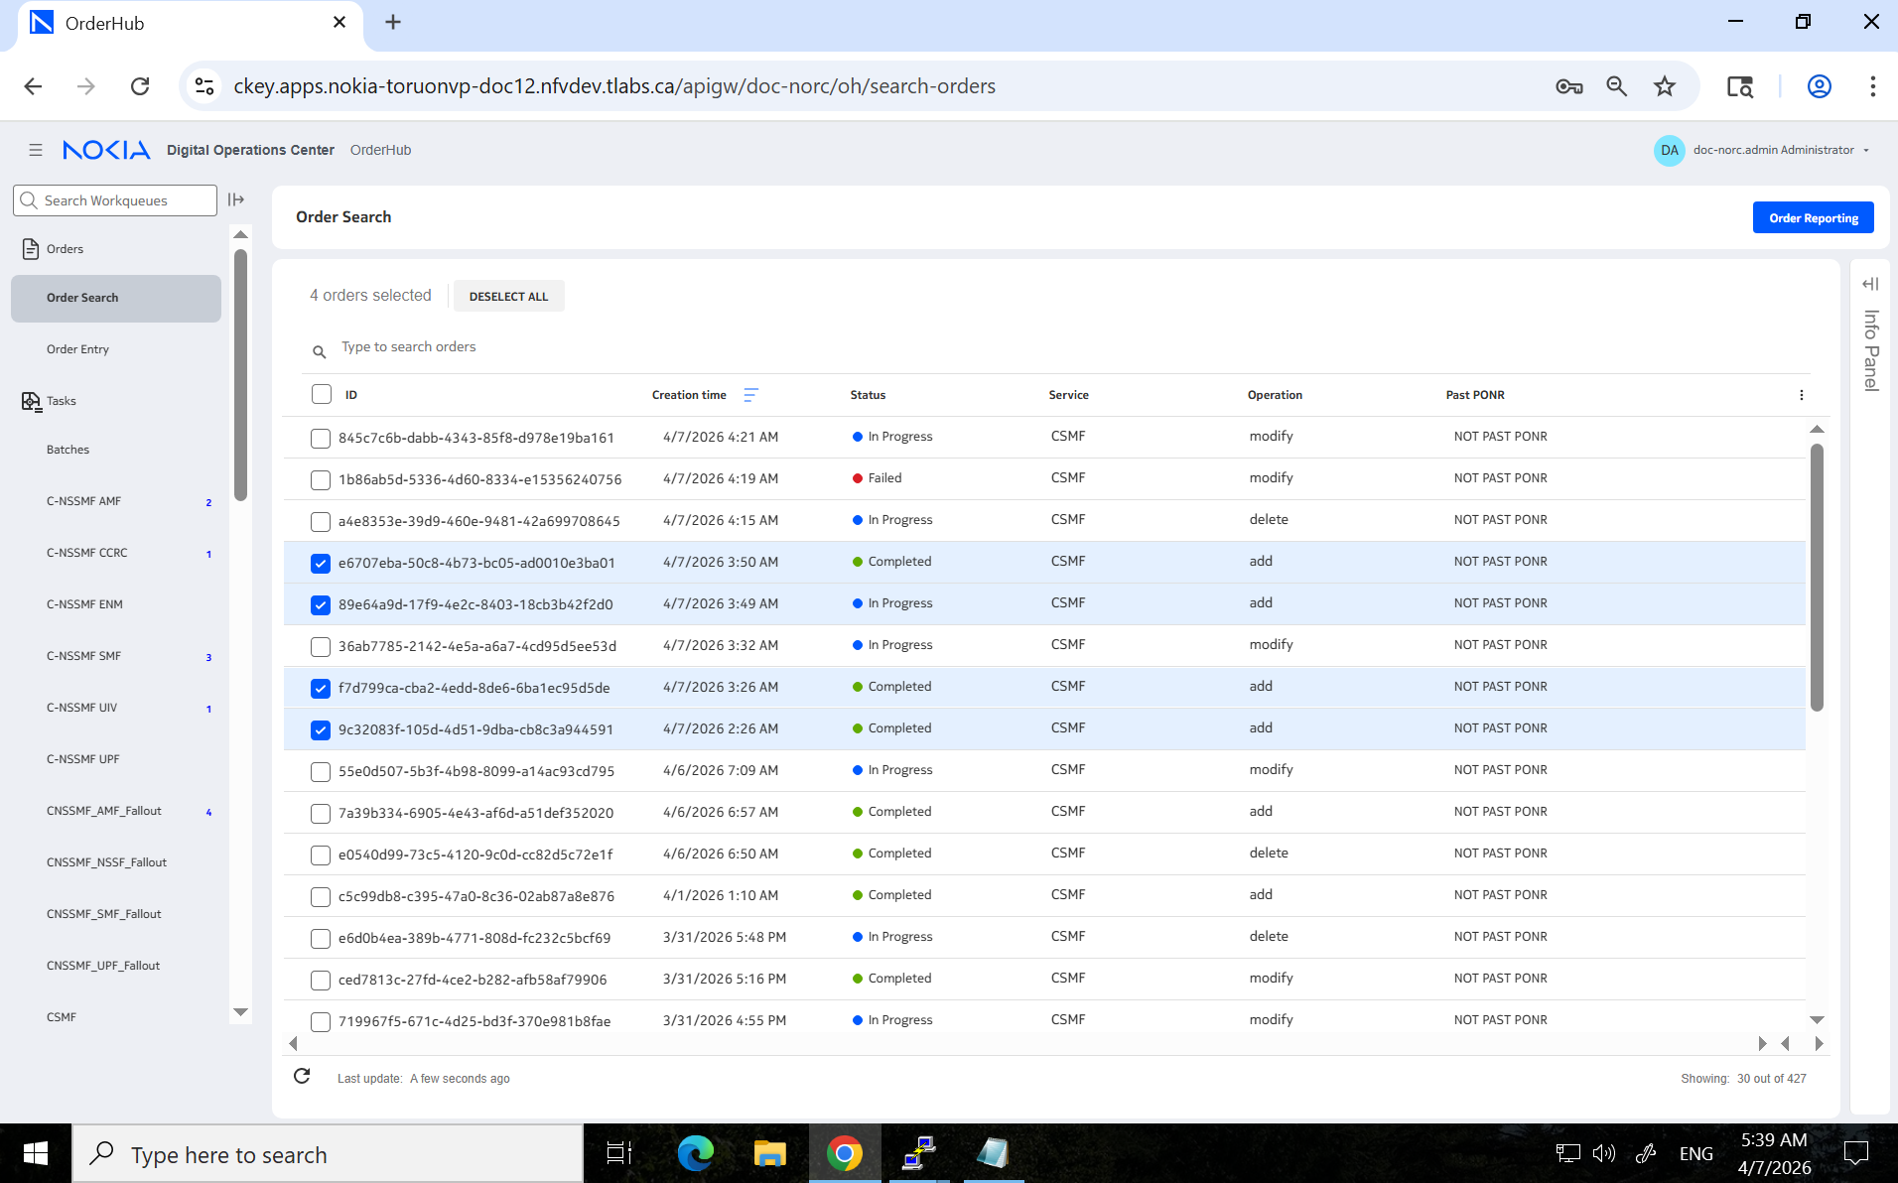
Expected output of order IDs created and visible in OrderHub UI

Verify backups
Verify that latest DB backups are available for UIV and NOrC using the command below
#kubectl -n <namespace> get brpolices.cbur.csf.nokia.com -o=jsonpath='{range .items[*]}{"==\n"}{.metadata.name}{"\n"}{range.status.backupHistory[*]}{@}{"\n"}{end}{end}' | grep <DB name>

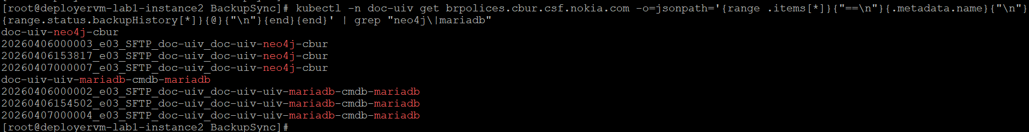

Verification of UIV DB backups
Verify existing backups of UIV DBs neo4j and mariadb.
Sample Output of UIV:
[root@deployervm-lab1-instance2 BackupSync]# kubectl -n doc-uiv get brpolices.cbur.csf.nokia.com -o=jsonpath='{range .items[*]}{"==\n"}{.metadata.name}{"\n"}{range.status.backupHistory[*]}{@}{"\n"}{end}{end}' | grep "neo4j\|mariadb"
doc-uiv-neo4j-cbur
20260406000003_e03_SFTP_doc-uiv_doc-uiv-neo4j-cbur
20260406153817_e03_SFTP_doc-uiv_doc-uiv-neo4j-cbur
20260407000007_e03_SFTP_doc-uiv_doc-uiv-neo4j-cbur
doc-uiv-uiv-mariadb-cmdb-mariadb
20260406000002_e03_SFTP_doc-uiv_doc-uiv-uiv-mariadb-cmdb-mariadb
20260406154502_e03_SFTP_doc-uiv_doc-uiv-uiv-mariadb-cmdb-mariadb
20260407000004_e03_SFTP_doc-uiv_doc-uiv-uiv-mariadb-cmdb-mariadb
[root@deployervm-lab1-instance2 BackupSync]#iadb-cmdb-mariadb
[root@deployervm-lab1-instance2 anycloudscript]#

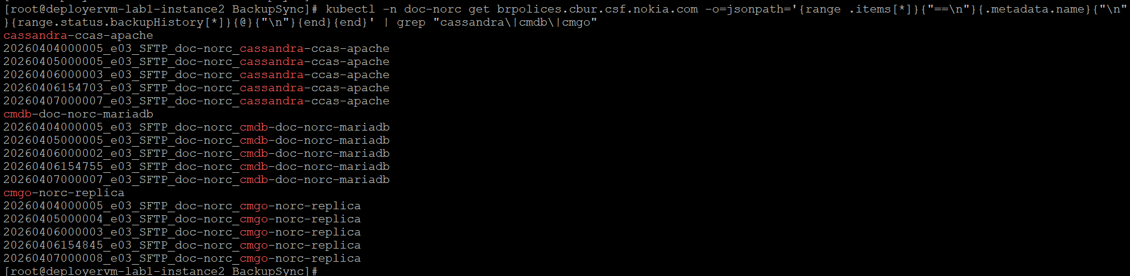

Verification of NOrC DB backups
Verify existing backups of UIV DBs neo4j and mariadb.
Sample Output of NOrC DB:
[root@deployervm-lab1-instance2 BackupSync]# kubectl -n doc-norc get brpolices.cbur.csf.nokia.com -o=jsonpath='{range .items[*]}{"==\n"}{.metadata.name}{"\n"}{range.status.backupHistory[*]}{@}{"\n"}{end}{end}' | grep "cassandra\|cmdb\|cmgo"
cassandra-ccas-apache
20260404000005_e03_SFTP_doc-norc_cassandra-ccas-apache
20260405000005_e03_SFTP_doc-norc_cassandra-ccas-apache
20260406000003_e03_SFTP_doc-norc_cassandra-ccas-apache
20260406154703_e03_SFTP_doc-norc_cassandra-ccas-apache
20260407000007_e03_SFTP_doc-norc_cassandra-ccas-apache
cmdb-doc-norc-mariadb
20260404000005_e03_SFTP_doc-norc_cmdb-doc-norc-mariadb
20260405000005_e03_SFTP_doc-norc_cmdb-doc-norc-mariadb
20260406000002_e03_SFTP_doc-norc_cmdb-doc-norc-mariadb
20260406154755_e03_SFTP_doc-norc_cmdb-doc-norc-mariadb
20260407000007_e03_SFTP_doc-norc_cmdb-doc-norc-mariadb
cmgo-norc-replica
20260404000005_e03_SFTP_doc-norc_cmgo-norc-replica
20260405000004_e03_SFTP_doc-norc_cmgo-norc-replica
20260406000003_e03_SFTP_doc-norc_cmgo-norc-replica
20260406154845_e03_SFTP_doc-norc_cmgo-norc-replica
20260407000008_e03_SFTP_doc-norc_cmgo-norc-replica
[root@deployervm-lab1-instance2 BackupSync]#

Identify helm name of DBs
Verify and fetch helm names for DBs using the command below
#./helm ls -a -n <namespace> <dbname>
Sample Output for UIV DB helm names:
[root@deployervm-lab1-instance2 anycloudscript]# helm ls -a -n doc-uiv | grep "neo4j-cbur\|cmdb"
doc-uiv-uiv-mariadb doc-uiv 1 2025-11-20 11:01:56.505222735 +0000 UTC deployed cmdb-9.5.2 cmdb-6.5.3_mariadb-10.11.11
doc-uiv-uiv-neo4j-cbur doc-uiv 2 2025-12-11 14:26:11.609008866 +0000 UTC deployed uiv-neo4j-cbur-25.7.2-137 5.26.4
[root@deployervm-lab1-instance2 ~]#

Sample Output for NOrC DB helm names:
[root@deployervm-lab1-instance2 anycloudscript]# helm ls -a -n doc-norc | grep "cassandra\|cmdb\|cmgo"
cassandra doc-norc 1 2025-11-20 17:21:03.48464813 +0000 UTC deployed ccas-apache-9.0.2 ccas-apache-3.0.1_cassandra-5.0.2
cmdb-doc-norc doc-norc 1 2025-11-20 17:21:23.735384775 +0000 UTC deployed cmdb-9.4.1 cmdb-6.4.1_mariadb-10.11.9
cmgo-norc doc-norc 1 2025-11-20 17:21:10.644505783 +0000 UTC deployed cmgo-25.0.0-7.295.5567 cmgo-7.0.22_mongodb-7.0.22-12.el8
[root@deployervm-lab1-instance2 anycloudscript]#

Activity Overview
The picture below depicts complete overview of the activity.
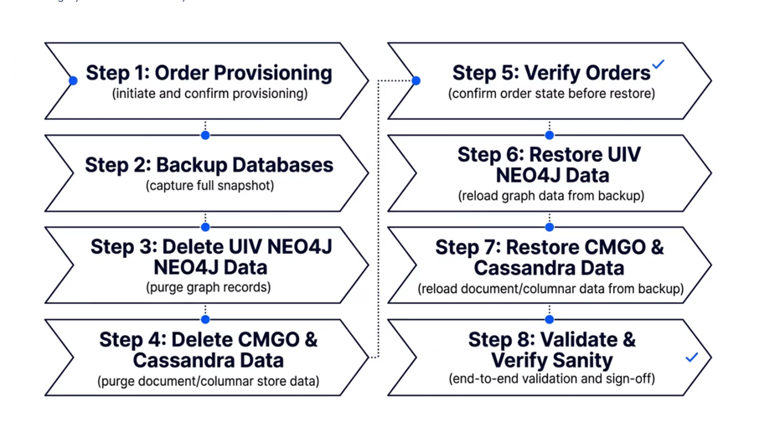

Backup Procedure and verification
Trigger on-demand backup for UIV and NOrC DBs using the commands below
#./ncs app backup --id <helm name>
NOTE: Ensure rsync task is completed on successful completion of on-demand backup.

On-demand backup of DBs

Backup of UIV neo4j DB
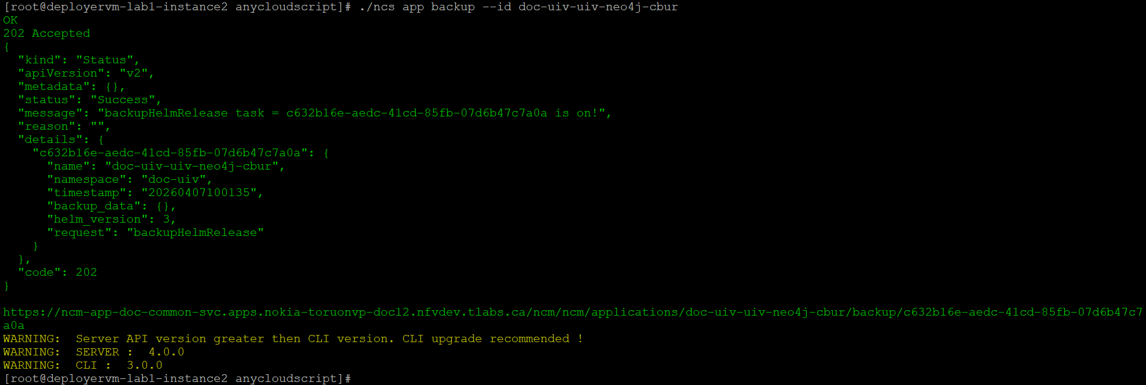
Expected output for UIV neo4j DB backup task:
[root@deployervm-lab1-instance2 anycloudscript]# ./ncs app backup --id doc-uiv-uiv-neo4j-cbur
OK
202 Accepted
{
"kind": "Status",
"apiVersion": "v2",
"metadata": {},
"status": "Success",
"message": "backupHelmRelease task = c632b16e-aedc-41cd-85fb-07d6b47c7a0a is on!",
"reason": "",
"details": {
"c632b16e-aedc-41cd-85fb-07d6b47c7a0a": {
"name": "doc-uiv-uiv-neo4j-cbur",
"namespace": "doc-uiv",
"timestamp": "20260407100135",
"backup_data": {},
"helm_version": 3,
"request": "backupHelmRelease"
}
},
"code": 202
}

https://ncm-app-doc-common-svc.apps.nokia-toruonvp-doc12.nfvdev.tlabs.ca/ncm/ncm/applications/doc-uiv-uiv-neo4j-cbur/backup/c632b16e-aedc-41cd-85fb-07d6b47c7a0a
WARNING: Server API version greater then CLI version. CLI upgrade recommended !
WARNING: SERVER : 4.0.0
WARNING: CLI : 3.0.0
[root@deployervm-lab1-instance2 anycloudscript]#

Backup of UIV mariadb DB
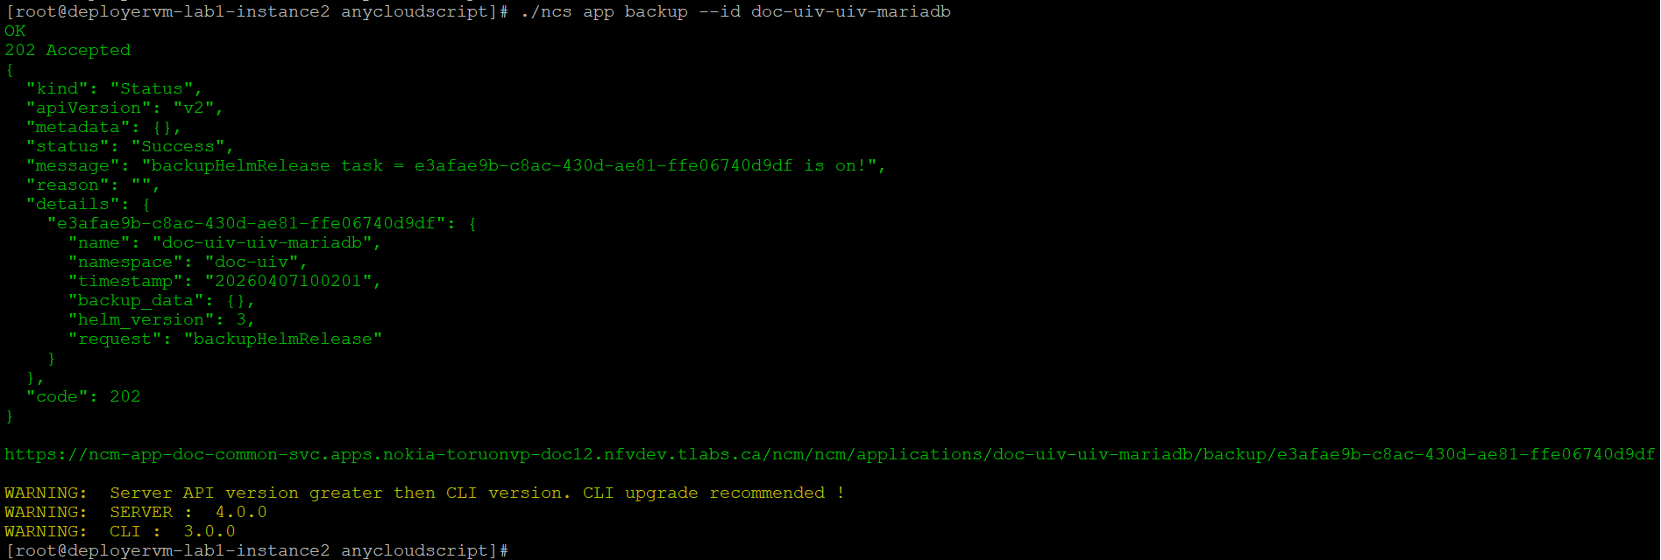
Expected output for UIV mariadb DB backup task:
[root@deployervm-lab1-instance2 anycloudscript]# ./ncs app backup --id doc-uiv-uiv-mariadb
OK
202 Accepted
{
"kind": "Status",
"apiVersion": "v2",
"metadata": {},
"status": "Success",
"message": "backupHelmRelease task = e3afae9b-c8ac-430d-ae81-ffe06740d9df is on!",
"reason": "",
"details": {
"e3afae9b-c8ac-430d-ae81-ffe06740d9df": {
"name": "doc-uiv-uiv-mariadb",
"namespace": "doc-uiv",
"timestamp": "20260407100201",
"backup_data": {},
"helm_version": 3,
"request": "backupHelmRelease"
}
},
"code": 202
}

https://ncm-app-doc-common-svc.apps.nokia-toruonvp-doc12.nfvdev.tlabs.ca/ncm/ncm/applications/doc-uiv-uiv-mariadb/backup/e3afae9b-c8ac-430d-ae81-ffe06740d9df
WARNING: Server API version greater then CLI version. CLI upgrade recommended !
WARNING: SERVER : 4.0.0
WARNING: CLI : 3.0.0
[root@deployervm-lab1-instance2 anycloudscript]#

Backup of NOrC cassandra DB
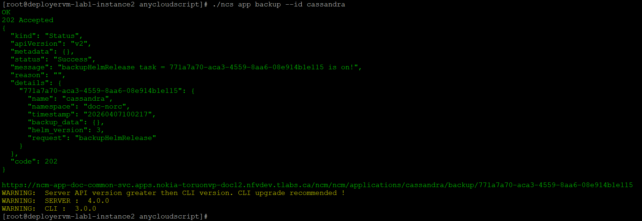
Expected output for NOrC Cassandra DB backup task:
[root@deployervm-lab1-instance2 anycloudscript]# ./ncs app backup --id cassandra
OK
202 Accepted
{
"kind": "Status",
"apiVersion": "v2",
"metadata": {},
"status": "Success",
"message": "backupHelmRelease task = 771a7a70-aca3-4559-8aa6-08e914b1e115 is on!",
"reason": "",
"details": {
"771a7a70-aca3-4559-8aa6-08e914b1e115": {
"name": "cassandra",
"namespace": "doc-norc",
"timestamp": "20260407100217",
"backup_data": {},
"helm_version": 3,
"request": "backupHelmRelease"
}
},
"code": 202
}

https://ncm-app-doc-common-svc.apps.nokia-toruonvp-doc12.nfvdev.tlabs.ca/ncm/ncm/applications/cassandra/backup/771a7a70-aca3-4559-8aa6-08e914b1e115
WARNING: Server API version greater then CLI version. CLI upgrade recommended !
WARNING: SERVER : 4.0.0
WARNING: CLI : 3.0.0
[root@deployervm-lab1-instance2 anycloudscript]#

Backup of NOrC CMDB DB
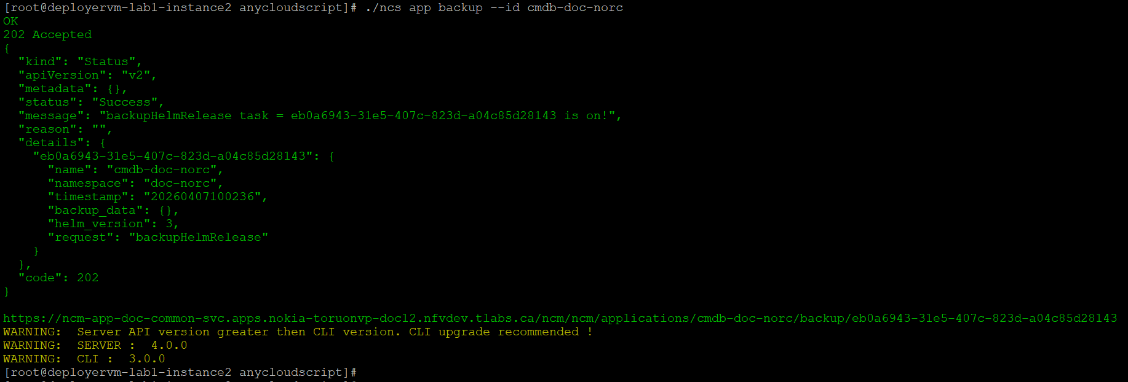
Expected output for NOrC cmdb DB backup task:
[root@deployervm-lab1-instance2 anycloudscript]# ./ncs app backup --id cmdb-doc-norc
OK
202 Accepted
{
"kind": "Status",
"apiVersion": "v2",
"metadata": {},
"status": "Success",
"message": "backupHelmRelease task = eb0a6943-31e5-407c-823d-a04c85d28143 is on!",
"reason": "",
"details": {
"eb0a6943-31e5-407c-823d-a04c85d28143": {
"name": "cmdb-doc-norc",
"namespace": "doc-norc",
"timestamp": "20260407100236",
"backup_data": {},
"helm_version": 3,
"request": "backupHelmRelease"
}
},
"code": 202
}
https://ncm-app-doc-common-svc.apps.nokia-toruonvp-doc12.nfvdev.tlabs.ca/ncm/ncm/applications/cmdb-doc-norc/backup/eb0a6943-31e5-407c-823d-a04c85d28143
WARNING: Server API version greater then CLI version. CLI upgrade recommended !
WARNING: SERVER : 4.0.0
WARNING: CLI : 3.0.0
[root@deployervm-lab1-instance2 anycloudscript]#

Backup of NOrC cmgo DB
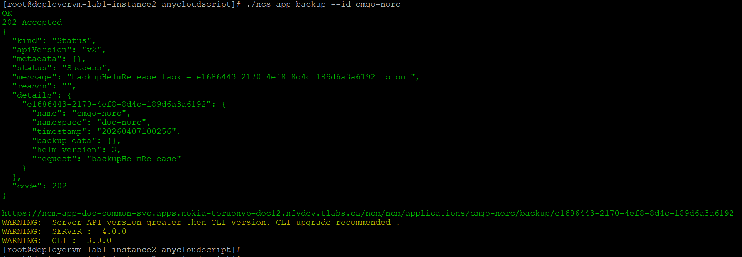
Expected output for NOrC cmgo DB backup task:
[root@deployervm-lab1-instance2 anycloudscript]# ./ncs app backup --id cmgo-norc
OK
202 Accepted
{
"kind": "Status",
"apiVersion": "v2",
"metadata": {},
"status": "Success",
"message": "backupHelmRelease task = e1686443-2170-4ef8-8d4c-189d6a3a6192 is on!",
"reason": "",
"details": {
"e1686443-2170-4ef8-8d4c-189d6a3a6192": {
"name": "cmgo-norc",
"namespace": "doc-norc",
"timestamp": "20260407100256",
"backup_data": {},
"helm_version": 3,
"request": "backupHelmRelease"
}
},
"code": 202
}

https://ncm-app-doc-common-svc.apps.nokia-toruonvp-doc12.nfvdev.tlabs.ca/ncm/ncm/applications/cmgo-norc/backup/e1686443-2170-4ef8-8d4c-189d6a3a6192
WARNING: Server API version greater then CLI version. CLI upgrade recommended !
WARNING: SERVER : 4.0.0
WARNING: CLI : 3.0.0
[root@deployervm-lab1-instance2 anycloudscript]#
Ensure rsync operation is triggered and completed after the backup activity.

Verification of DB backups created
Verify that the triggered on-demand backups are created successfully for UIV and NOrC DB.

Verification of on-demand UIV DB backup
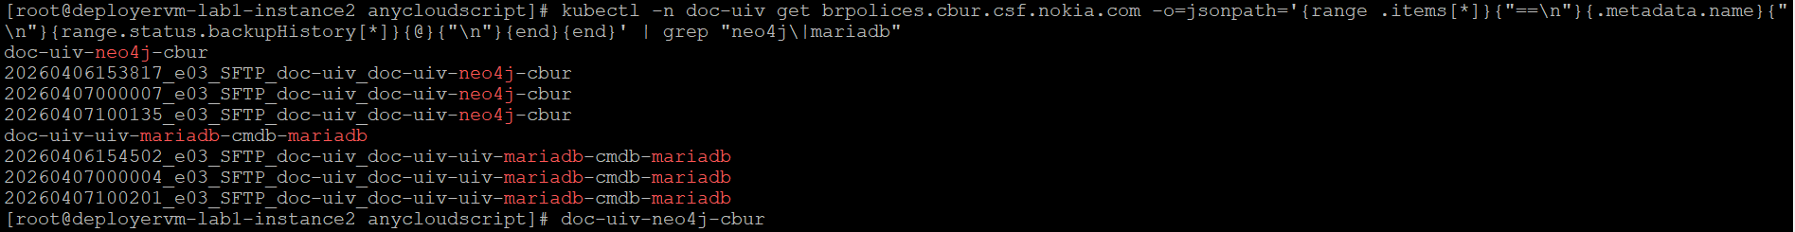
Expected output for verification of on-demand backups of UIV DBs:
[root@deployervm-lab1-instance2 anycloudscript]# kubectl -n doc-uiv get brpolices.cbur.csf.nokia.com -o=jsonpath='{range .items[*]}{"==\n"}{.metadata.name}{"\n"}{range.status.backupHistory[*]}{@}{"\n"}{end}{end}' | grep "neo4j\|mariadb"
doc-uiv-neo4j-cbur
20260406153817_e03_SFTP_doc-uiv_doc-uiv-neo4j-cbur
20260407000007_e03_SFTP_doc-uiv_doc-uiv-neo4j-cbur
20260407100135_e03_SFTP_doc-uiv_doc-uiv-neo4j-cbur
doc-uiv-uiv-mariadb-cmdb-mariadb
20260406154502_e03_SFTP_doc-uiv_doc-uiv-uiv-mariadb-cmdb-mariadb
20260407000004_e03_SFTP_doc-uiv_doc-uiv-uiv-mariadb-cmdb-mariadb
20260407100201_e03_SFTP_doc-uiv_doc-uiv-uiv-mariadb-cmdb-mariadb
[root@deployervm-lab1-instance2 anycloudscript]#

Verification of on-demand NOrC DB backup
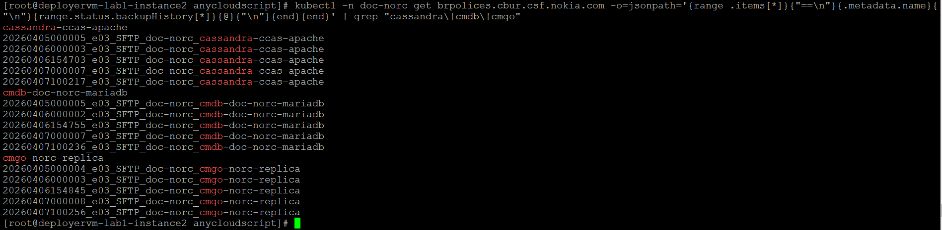
Expected output for verification of on-demand backups of NOrC DBs:
[root@deployervm-lab1-instance2 anycloudscript]# kubectl -n doc-norc get brpolices.cbur.csf.nokia.com -o=jsonpath='{range .items[*]}{"==\n"}{.metadata.name}{"\n"}{range.status.backupHistory[*]}{@}{"\n"}{end}{end}' | grep "cassandra\|cmdb\|cmgo"
cassandra-ccas-apache
20260405000005_e03_SFTP_doc-norc_cassandra-ccas-apache
20260406000003_e03_SFTP_doc-norc_cassandra-ccas-apache
20260406154703_e03_SFTP_doc-norc_cassandra-ccas-apache
20260407000007_e03_SFTP_doc-norc_cassandra-ccas-apache
20260407100217_e03_SFTP_doc-norc_cassandra-ccas-apache
cmdb-doc-norc-mariadb
20260405000005_e03_SFTP_doc-norc_cmdb-doc-norc-mariadb
20260406000002_e03_SFTP_doc-norc_cmdb-doc-norc-mariadb
20260406154755_e03_SFTP_doc-norc_cmdb-doc-norc-mariadb
20260407000007_e03_SFTP_doc-norc_cmdb-doc-norc-mariadb
20260407100236_e03_SFTP_doc-norc_cmdb-doc-norc-mariadb
cmgo-norc-replica
20260405000004_e03_SFTP_doc-norc_cmgo-norc-replica
20260406000003_e03_SFTP_doc-norc_cmgo-norc-replica
20260406154845_e03_SFTP_doc-norc_cmgo-norc-replica
20260407000008_e03_SFTP_doc-norc_cmgo-norc-replica
20260407100256_e03_SFTP_doc-norc_cmgo-norc-replica
[root@deployervm-lab1-instance2 anycloudscript]#

Data purging and verification

Data purging of Cassandra DB
Login to cassandra pod (any replica) and truncate tables (check credentials from configuration-ccas-credentials-secret)
[root@deployer-node ~]# oc exec -it cassandra-ccas-apache-0 -n doc-norc -- bash
bash-4.4$
#/opt/cassandra/bin/cqlsh $(hostname -i) -u <suadmincass> -p <password>

Truncate the tables by using the commands below:

truncate norc_order_processing.admin_order_state;
truncate norc_order_processing.aggregation_element_event;
truncate norc_order_processing.async_invocation;
truncate norc_order_processing.async_schedule;
truncate norc_order_processing.capability_request;
truncate norc_order_processing.child_workflow;
truncate norc_order_processing.commit_position;
truncate norc_order_processing.event;
truncate norc_order_processing.event_subscription;
truncate norc_order_processing.gr_data_center;
truncate norc_order_processing.lock_list_entry;
truncate norc_order_processing.node_state;
truncate norc_order_processing.order_correlation;
truncate norc_order_processing.order_execution;
truncate norc_order_processing.order_item_update;
truncate norc_order_processing.order_update;
truncate norc_order_processing.orders;
truncate norc_order_processing.recovery_process;
truncate norc_order_processing.schema_migration;
truncate norc_order_processing.schema_migration_leader;
truncate norc_order_processing.workflow_execution;
truncate norc_order_processing.workflow_lock_request;
truncate norc_order_processing.workflow_rollback;
truncate norc_order_processing.workflow_rollback_in_order;
truncate norc_generic_type_driver.commit_position;
truncate norc_generic_type_driver.gr_data_center;
truncate norc_generic_type_driver.gr_data_center;
truncate norc_generic_type_driver.stashed_message;
truncate norc_generic_type_driver.stashed_message_live_range;
truncate norc_generic_type_driver.ne_partition_assignment;
truncate norc_generic_type_driver.reprocessed_request;

Data purging of neo4j DB

Verification of data count pre purge activity
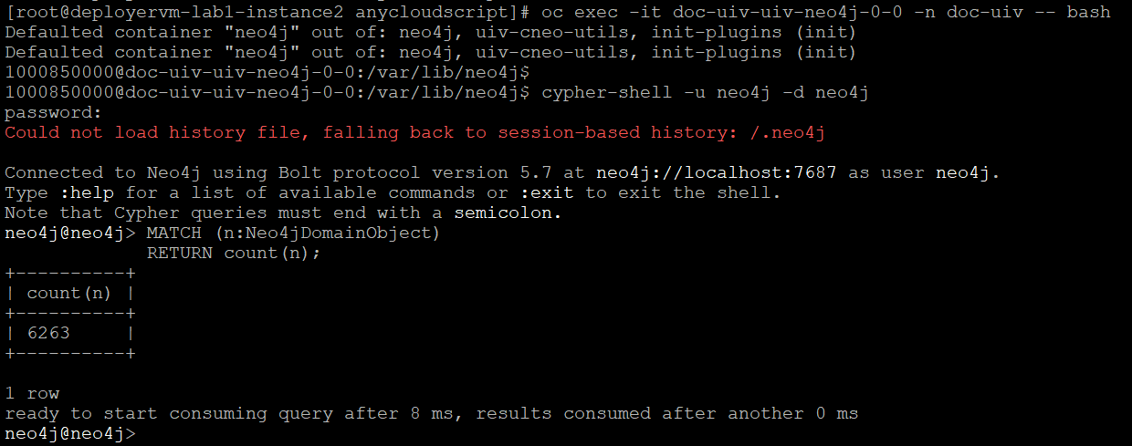

Purging data activity
#match(n:Neo4jDomainObject) detach delete n;
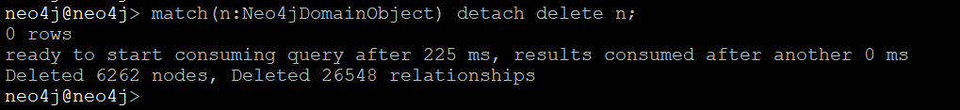

Verification of data count post purge activity
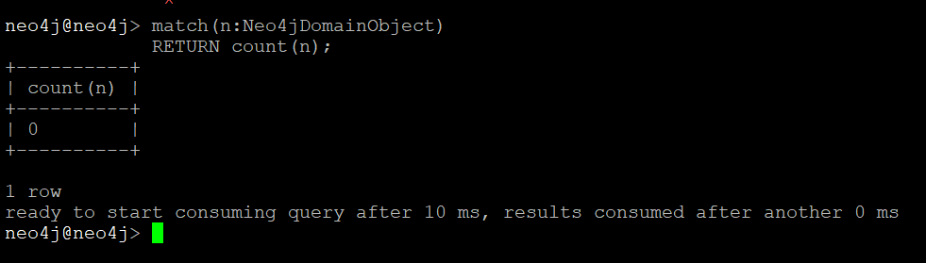

Data purging of cmgo DB

Verification of data count pre purge activity
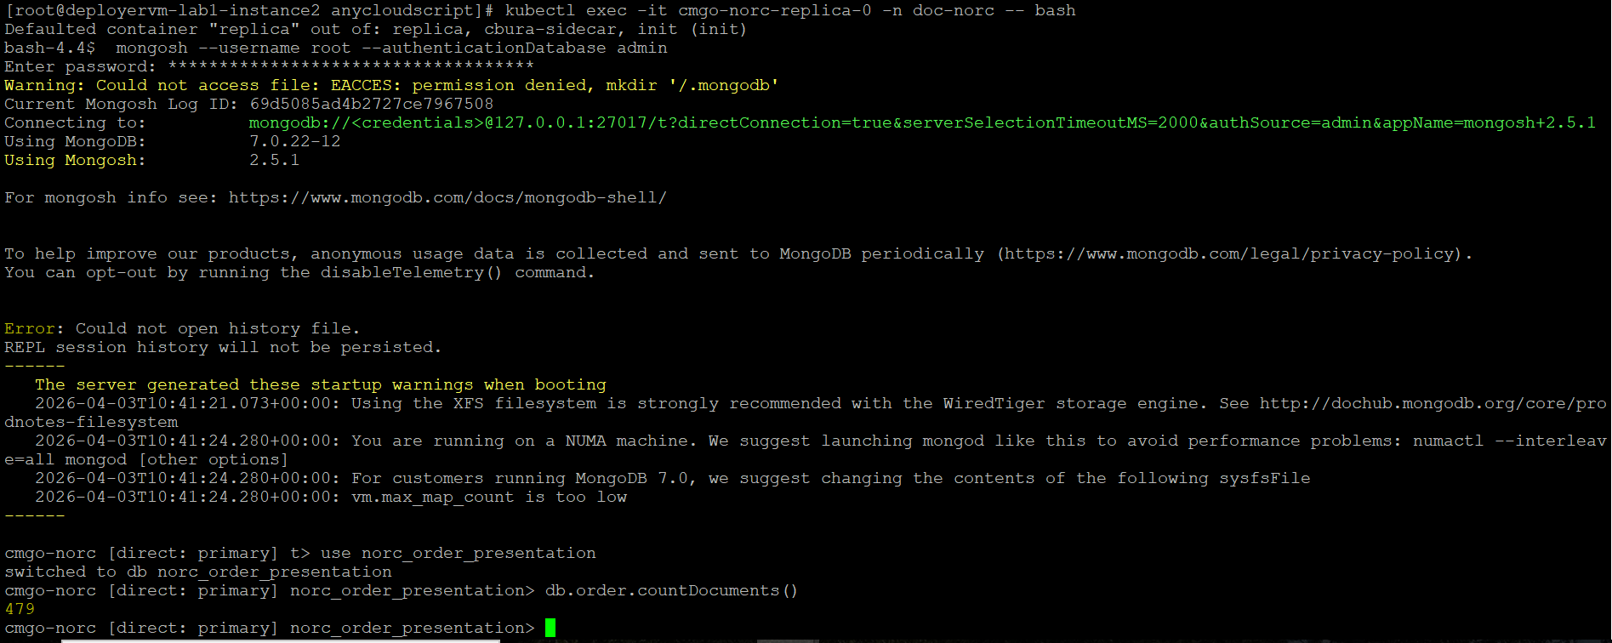
[root@deployervm-lab1-instance2 anycloudscript]# kubectl exec -it cmgo-norc-replica-0 -n doc-norc -- bash
Defaulted container "replica" out of: replica, cbura-sidecar, init (init)
bash-4.4$ mongosh --username root --authenticationDatabase admin
Enter password: ************************************
Warning: Could not access file: EACCES: permission denied, mkdir '/.mongodb'
Current Mongosh Log ID: 69d5085ad4b2727ce7967508
Connecting to: mongodb://<credentials>@127.0.0.1:27017/t?directConnection=true&serverSelectionTimeoutMS=2000&authSource=admin&appName=mongosh+2.5.1
Using MongoDB: 7.0.22-12
Using Mongosh: 2.5.1

For mongosh info see: https://www.mongodb.com/docs/mongodb-shell/

To help improve our products, anonymous usage data is collected and sent to MongoDB periodically (https://www.mongodb.com/legal/privacy-policy).
You can opt-out by running the disableTelemetry() command.

Error: Could not open history file.
REPL session history will not be persisted.
------
The server generated these startup warnings when booting
2026-04-03T10:41:21.073+00:00: Using the XFS filesystem is strongly recommended with the WiredTiger storage engine. See http://dochub.mongodb.org/core/prodnotes-filesystem
2026-04-03T10:41:24.280+00:00: You are running on a NUMA machine. We suggest launching mongod like this to avoid performance problems: numactl --interleave=all mongod [other options]
2026-04-03T10:41:24.280+00:00: For customers running MongoDB 7.0, we suggest changing the contents of the following sysfsFile
2026-04-03T10:41:24.280+00:00: vm.max_map_count is too low
------

cmgo-norc [direct: primary] t> use norc_order_presentation
switched to db norc_order_presentation
cmgo-norc [direct: primary] norc_order_presentation> db.order.countDocuments()
479
cmgo-norc [direct: primary] norc_order_presentation>

Purging data activity
#db.order.deleteMany({})
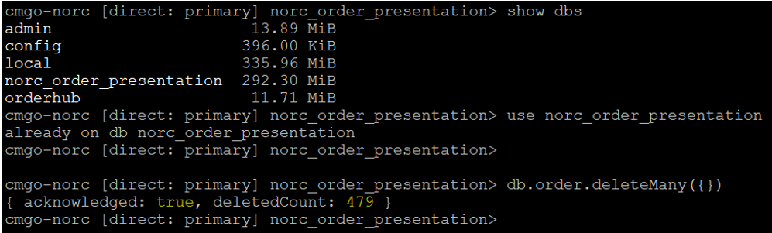
#db.tasks.deleteMany({})

cmgo-norc [direct: primary] norc_order_presentation> use orderhub
switched to db orderhub
cmgo-norc [direct: primary] orderhub> db.order.countDocuments()
0
cmgo-norc [direct: primary] orderhub> db.tasks.countDocuments()
6933
cmgo-norc [direct: primary] orderhub> db.tasks.deleteMany({})
{ acknowledged: true, deletedCount: 6933 }
cmgo-norc [direct: primary] orderhub> db.tasks.countDocuments()
0
cmgo-norc [direct: primary] orderhub>

Verification of data count post purge activity
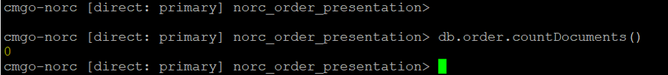

Verification of OrderHub UI
Login to OrderHub UI and verify that the orders IDs are deleted

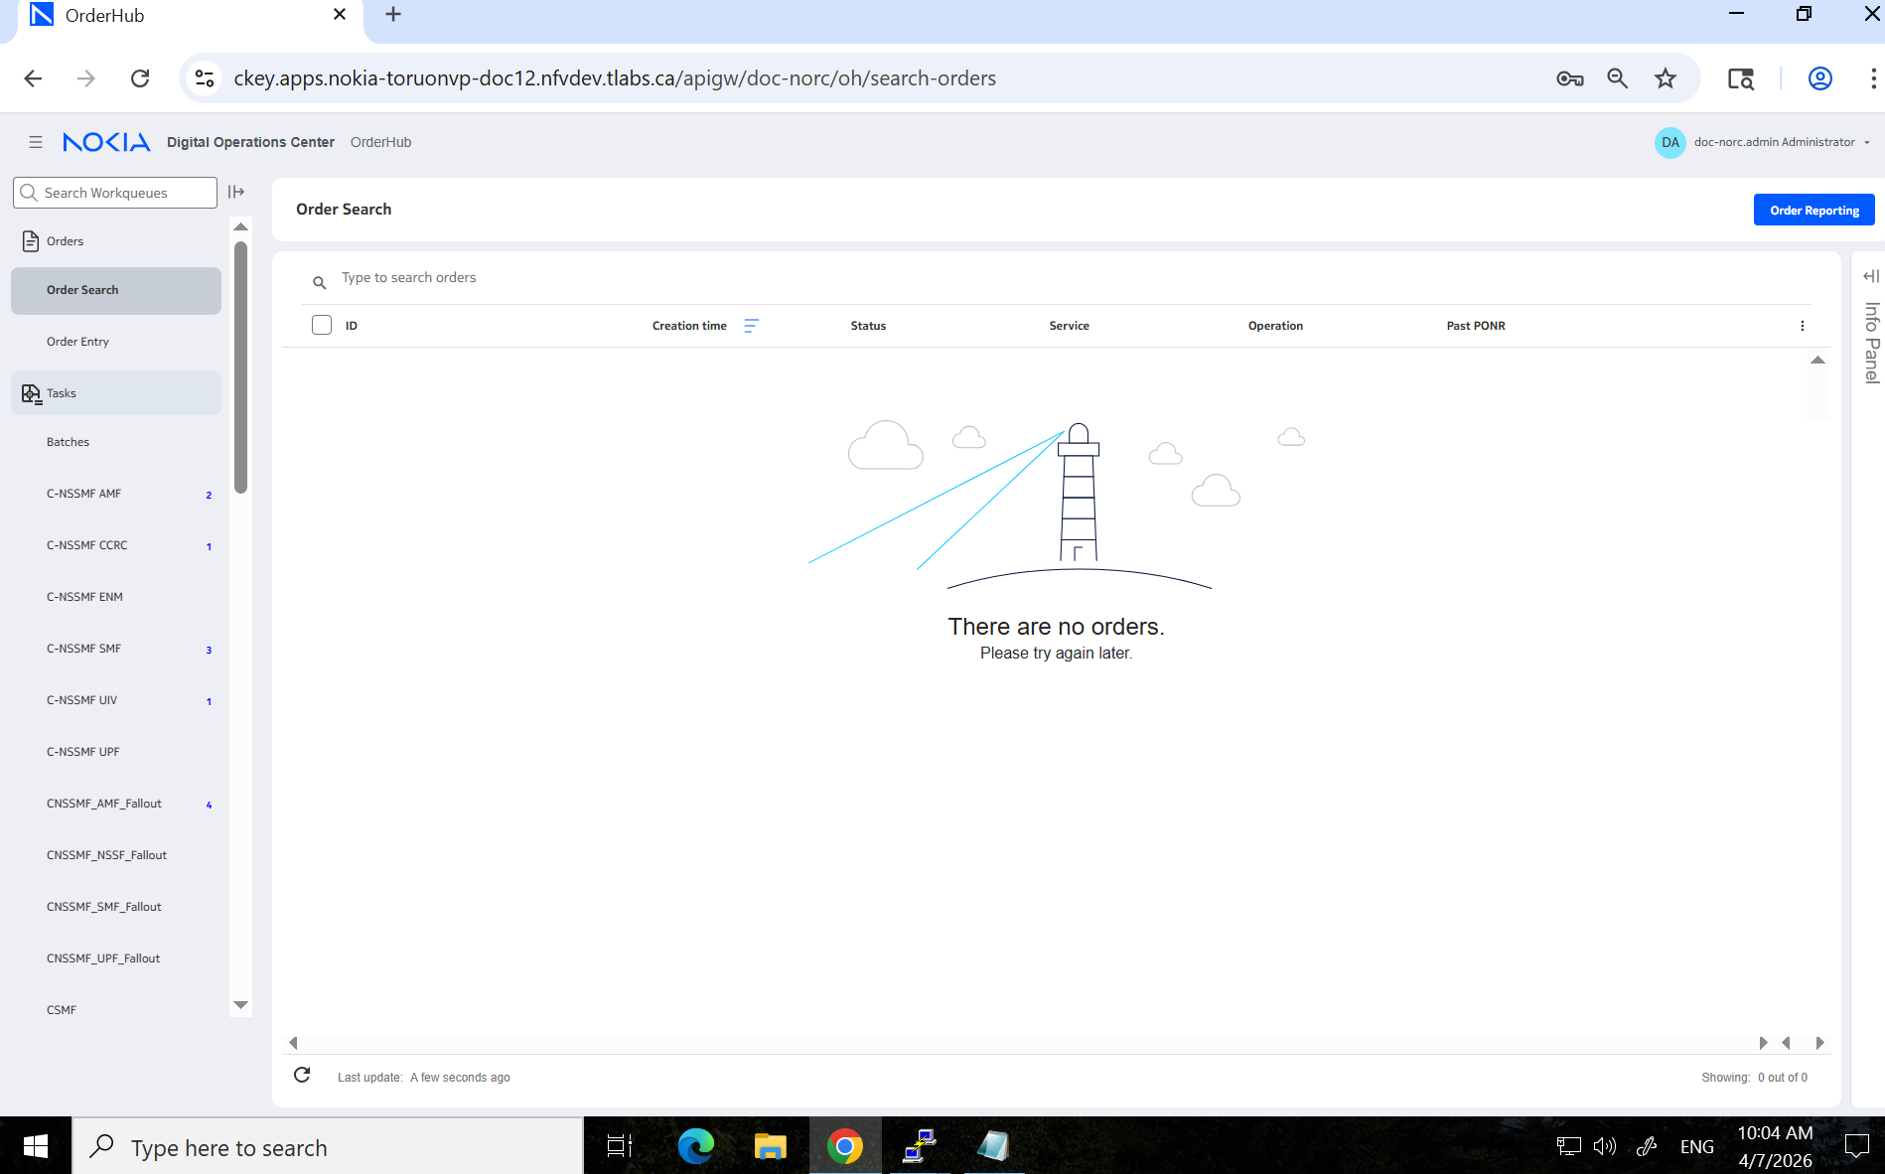
Expected output of OrderHub UI with no order IDs post deletion

Restore DB data and verification

Restore of DB from on-demand backup
#./ncs app restore –id <helm name> –backup_id=<backupid_replica>

Restore of neo4j DB
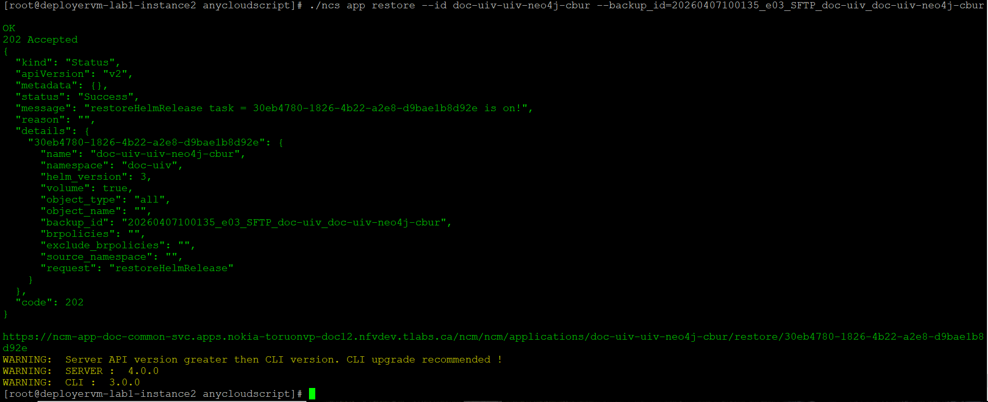
[root@deployervm-lab1-instance2 anycloudscript]# ./ncs app restore --id doc-uiv-uiv-neo4j-cbur --backup_id=20260407100135_e03_SFTP_doc-uiv_doc-uiv-neo4j-cbur
OK
202 Accepted
{
"kind": "Status",
"apiVersion": "v2",
"metadata": {},
"status": "Success",
"message": "restoreHelmRelease task = 30eb4780-1826-4b22-a2e8-d9bae1b8d92e is on!",
"reason": "",
"details": {
"30eb4780-1826-4b22-a2e8-d9bae1b8d92e": {
"name": "doc-uiv-uiv-neo4j-cbur",
"namespace": "doc-uiv",
"helm_version": 3,
"volume": true,
"object_type": "all",
"object_name": "",
"backup_id": "20260407100135_e03_SFTP_doc-uiv_doc-uiv-neo4j-cbur",
"brpolicies": "",
"exclude_brpolicies": "",
"source_namespace": "",
"request": "restoreHelmRelease"
}
},
"code": 202
}

https://ncm-app-doc-common-svc.apps.nokia-toruonvp-doc12.nfvdev.tlabs.ca/ncm/ncm/applications/doc-uiv-uiv-neo4j-cbur/restore/30eb4780-1826-4b22-a2e8-d9bae1b8d92e
WARNING: Server API version greater then CLI version. CLI upgrade recommended !
WARNING: SERVER : 4.0.0
WARNING: CLI : 3.0.0
[root@deployervm-lab1-instance2 anycloudscript]#

Restore mariadb DB
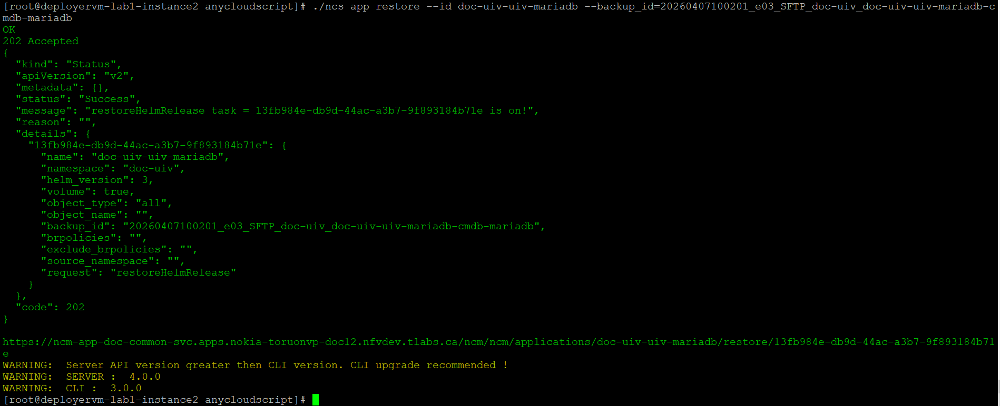
[root@deployervm-lab1-instance2 anycloudscript]# ./ncs app restore --id doc-uiv-uiv-mariadb --backup_id=20260407100201_e03_SFTP_doc-uiv_doc-uiv-uiv-mariadb-cmdb-mariadb
OK
202 Accepted
{
"kind": "Status",
"apiVersion": "v2",
"metadata": {},
"status": "Success",
"message": "restoreHelmRelease task = 13fb984e-db9d-44ac-a3b7-9f893184b71e is on!",
"reason": "",
"details": {
"13fb984e-db9d-44ac-a3b7-9f893184b71e": {
"name": "doc-uiv-uiv-mariadb",
"namespace": "doc-uiv",
"helm_version": 3,
"volume": true,
"object_type": "all",
"object_name": "",
"backup_id": "20260407100201_e03_SFTP_doc-uiv_doc-uiv-uiv-mariadb-cmdb-mariadb",
"brpolicies": "",
"exclude_brpolicies": "",
"source_namespace": "",
"request": "restoreHelmRelease"
}
},
"code": 202
}

https://ncm-app-doc-common-svc.apps.nokia-toruonvp-doc12.nfvdev.tlabs.ca/ncm/ncm/applications/doc-uiv-uiv-mariadb/restore/13fb984e-db9d-44ac-a3b7-9f893184b71e
WARNING: Server API version greater then CLI version. CLI upgrade recommended !
WARNING: SERVER : 4.0.0
WARNING: CLI : 3.0.0
[root@deployervm-lab1-instance2 anycloudscript]#

Restore cassandra DB
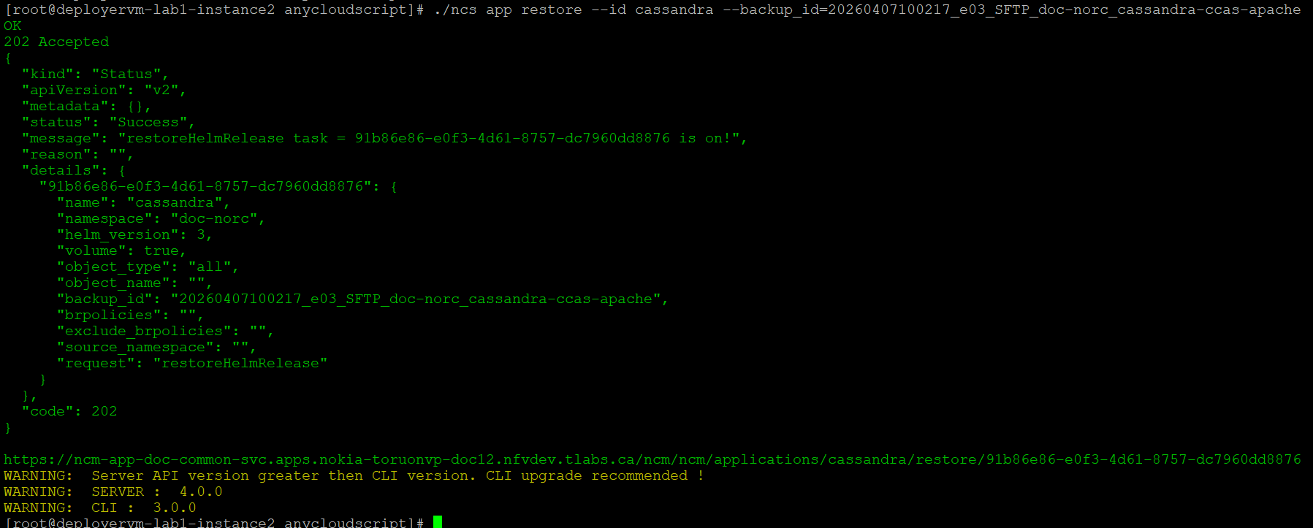
[root@deployervm-lab1-instance2 anycloudscript]# ./ncs app restore --id cassandra --backup_id=20260407100217_e03_SFTP_doc-norc_cassandra-ccas-apache
OK
202 Accepted
{
"kind": "Status",
"apiVersion": "v2",
"metadata": {},
"status": "Success",
"message": "restoreHelmRelease task = 91b86e86-e0f3-4d61-8757-dc7960dd8876 is on!",
"reason": "",
"details": {
"91b86e86-e0f3-4d61-8757-dc7960dd8876": {
"name": "cassandra",
"namespace": "doc-norc",
"helm_version": 3,
"volume": true,
"object_type": "all",
"object_name": "",
"backup_id": "20260407100217_e03_SFTP_doc-norc_cassandra-ccas-apache",
"brpolicies": "",
"exclude_brpolicies": "",
"source_namespace": "",
"request": "restoreHelmRelease"
}
},
"code": 202
}

https://ncm-app-doc-common-svc.apps.nokia-toruonvp-doc12.nfvdev.tlabs.ca/ncm/ncm/applications/cassandra/restore/91b86e86-e0f3-4d61-8757-dc7960dd8876
WARNING: Server API version greater then CLI version. CLI upgrade recommended !
WARNING: SERVER : 4.0.0
WARNING: CLI : 3.0.0
[root@deployervm-lab1-instance2 anycloudscript]#

Restore cmdb DB
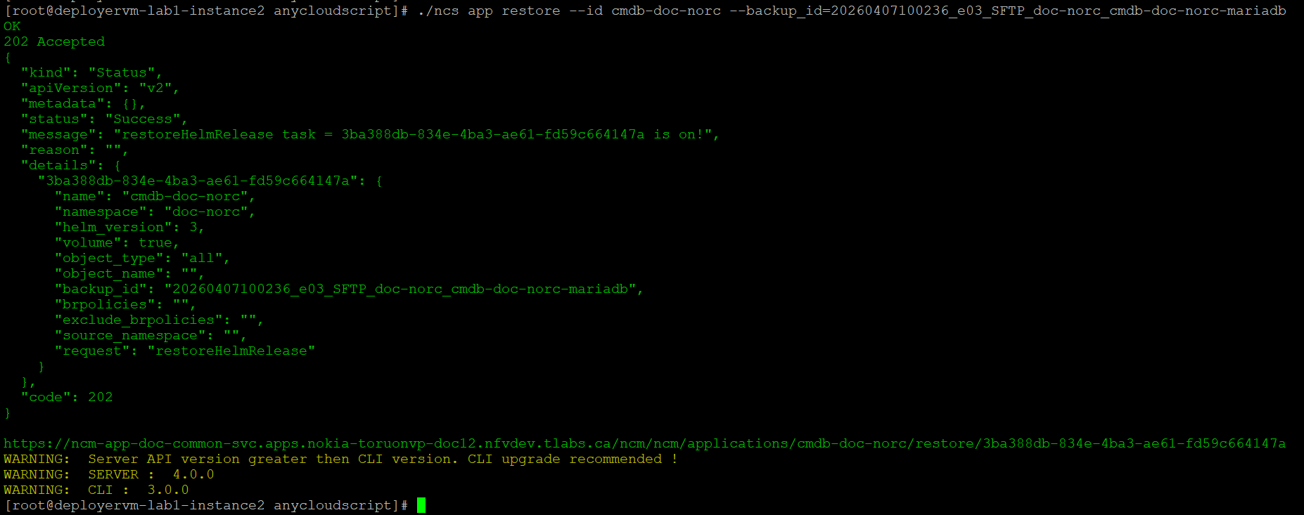
[root@deployervm-lab1-instance2 anycloudscript]# ./ncs app restore --id cmdb-doc-norc --backup_id=20260407100236_e03_SFTP_doc-norc_cmdb-doc-norc-mariadb
OK
202 Accepted
{
"kind": "Status",
"apiVersion": "v2",
"metadata": {},
"status": "Success",
"message": "restoreHelmRelease task = 3ba388db-834e-4ba3-ae61-fd59c664147a is on!",
"reason": "",
"details": {
"3ba388db-834e-4ba3-ae61-fd59c664147a": {
"name": "cmdb-doc-norc",
"namespace": "doc-norc",
"helm_version": 3,
"volume": true,
"object_type": "all",
"object_name": "",
"backup_id": "20260407100236_e03_SFTP_doc-norc_cmdb-doc-norc-mariadb",
"brpolicies": "",
"exclude_brpolicies": "",
"source_namespace": "",
"request": "restoreHelmRelease"
}
},
"code": 202
}

https://ncm-app-doc-common-svc.apps.nokia-toruonvp-doc12.nfvdev.tlabs.ca/ncm/ncm/applications/cmdb-doc-norc/restore/3ba388db-834e-4ba3-ae61-fd59c664147a
WARNING: Server API version greater then CLI version. CLI upgrade recommended !
WARNING: SERVER : 4.0.0
WARNING: CLI : 3.0.0
[root@deployervm-lab1-instance2 anycloudscript]#

Restore cmgo DB
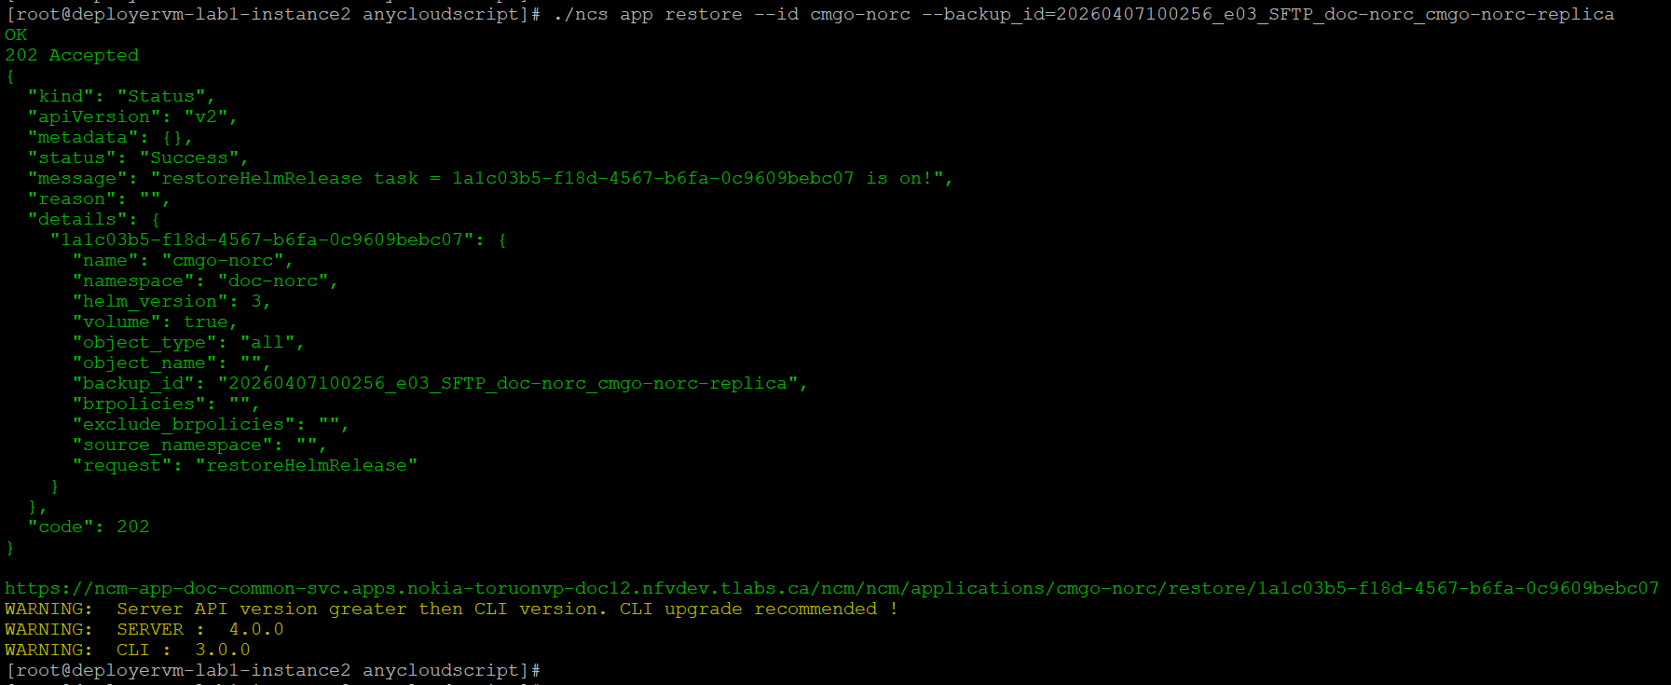
[root@deployervm-lab1-instance2 anycloudscript]# ./ncs app restore --id cmgo-norc --backup_id=20260407100256_e03_SFTP_doc-norc_cmgo-norc-replica
OK
202 Accepted
{
"kind": "Status",
"apiVersion": "v2",
"metadata": {},
"status": "Success",
"message": "restoreHelmRelease task = 1a1c03b5-f18d-4567-b6fa-0c9609bebc07 is on!",
"reason": "",
"details": {
"1a1c03b5-f18d-4567-b6fa-0c9609bebc07": {
"name": "cmgo-norc",
"namespace": "doc-norc",
"helm_version": 3,
"volume": true,
"object_type": "all",
"object_name": "",
"backup_id": "20260407100256_e03_SFTP_doc-norc_cmgo-norc-replica",
"brpolicies": "",
"exclude_brpolicies": "",
"source_namespace": "",
"request": "restoreHelmRelease"
}
},
"code": 202
}

https://ncm-app-doc-common-svc.apps.nokia-toruonvp-doc12.nfvdev.tlabs.ca/ncm/ncm/applications/cmgo-norc/restore/1a1c03b5-f18d-4567-b6fa-0c9609bebc07
WARNING: Server API version greater then CLI version. CLI upgrade recommended !
WARNING: SERVER : 4.0.0
WARNING: CLI : 3.0.0
[root@deployervm-lab1-instance2 anycloudscript]#

Verification post restore activity

Verification of cbur pod logs
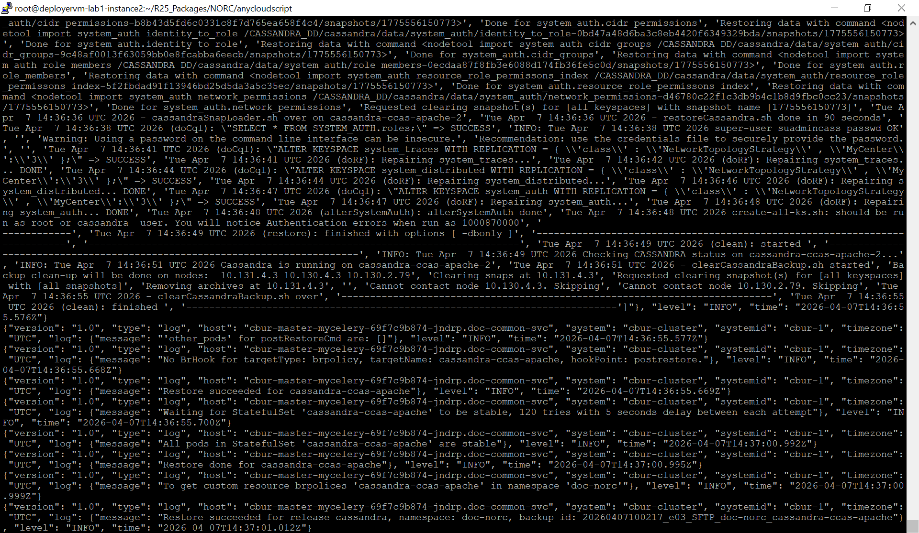

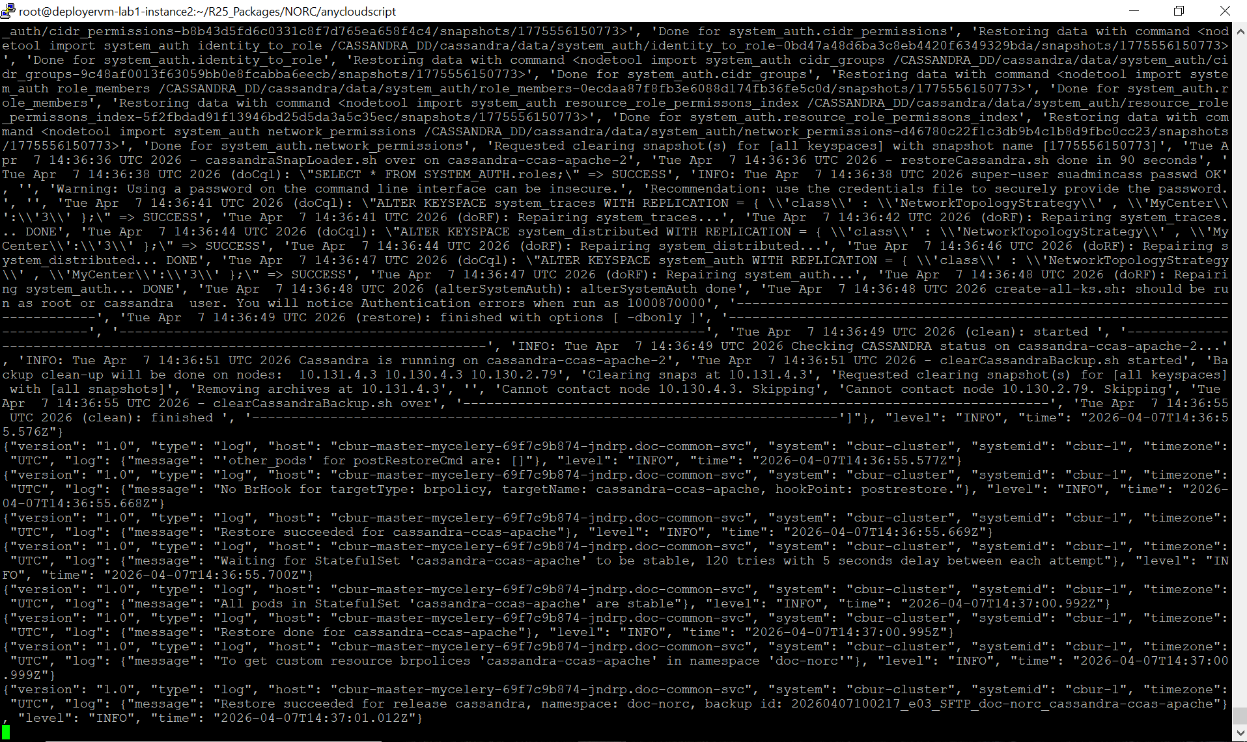

Verification of data count post restore activity
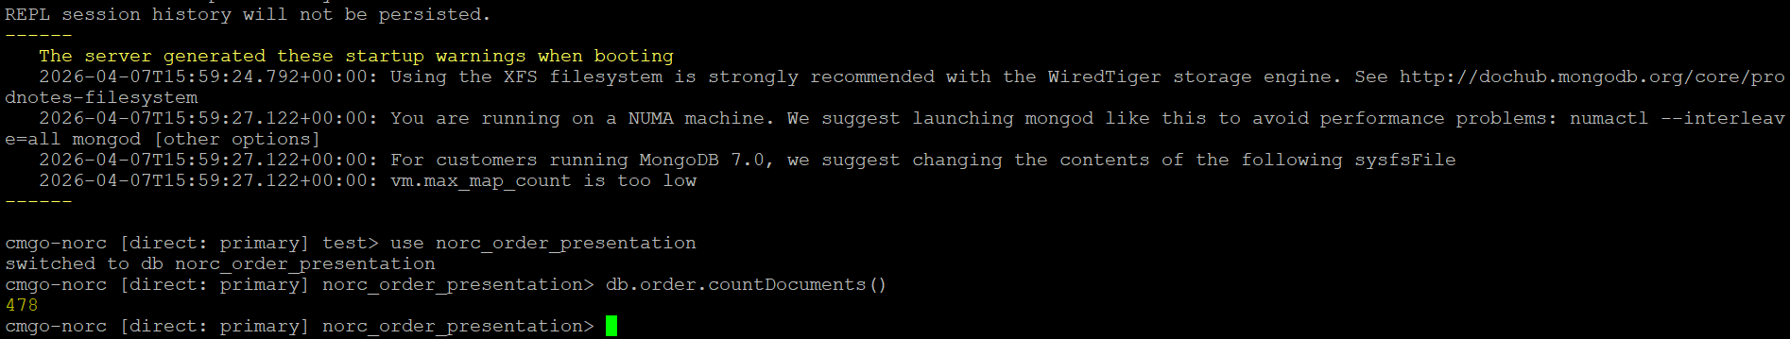

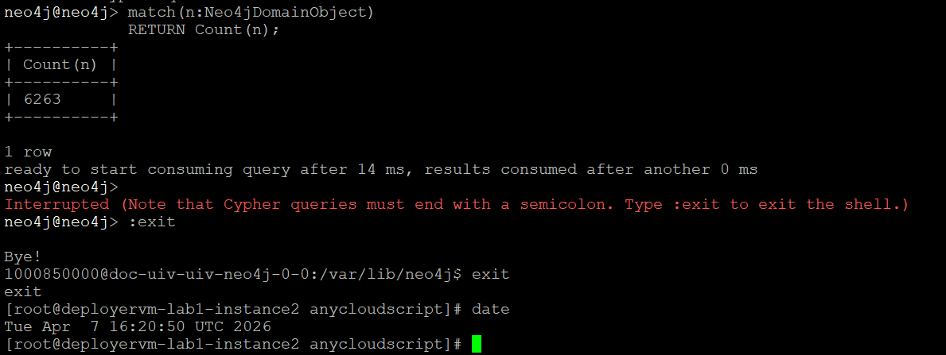

Verification of OrderHub UI
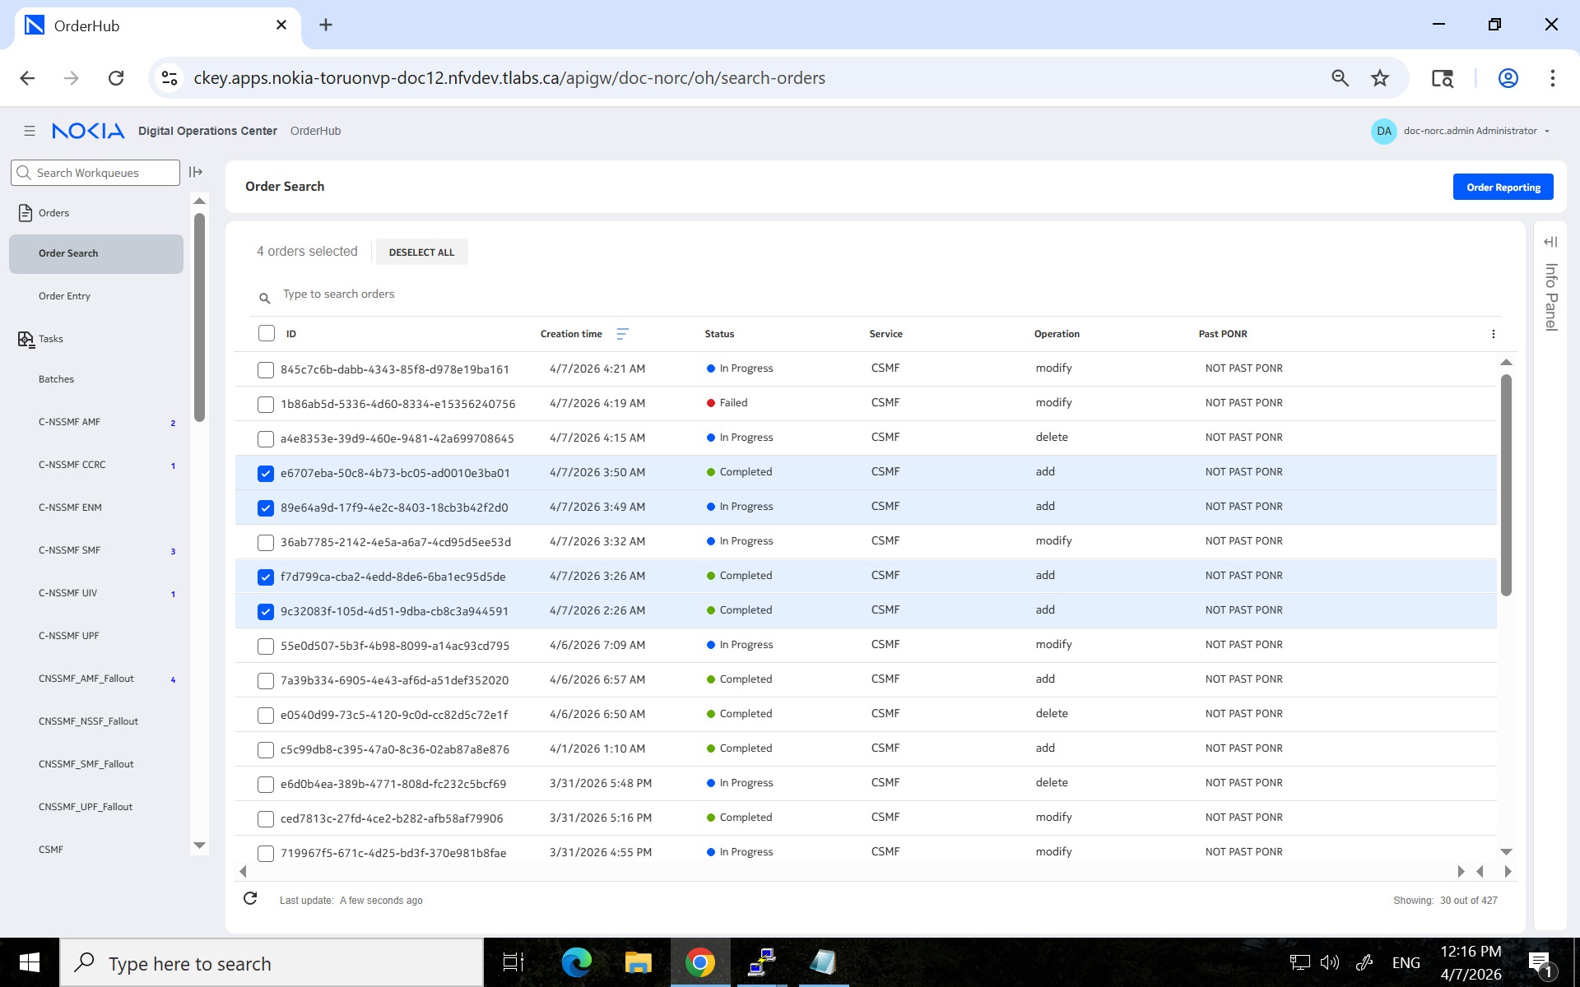
Expected output of OrderHub UI with order IDs post successful restore activity

